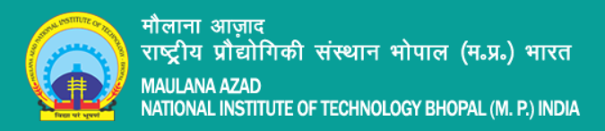

Data Warehousing & Mining Lab

Assignment

Lab - 9

Sub Code: CSE-326

Date: 13-04-2022

**Vivek Kumar Ahirwar**

**191112419**

**CSE - 3**

Department:

*Computer Science and Engineering*

Contents

A. Method 1 2

i. Read CSV File 2

ii. Read Excel File 2

B. Method 2 3

iii. Read CSV file 3

iv. Read Excel file 3

# Method 1

### Read CSV File

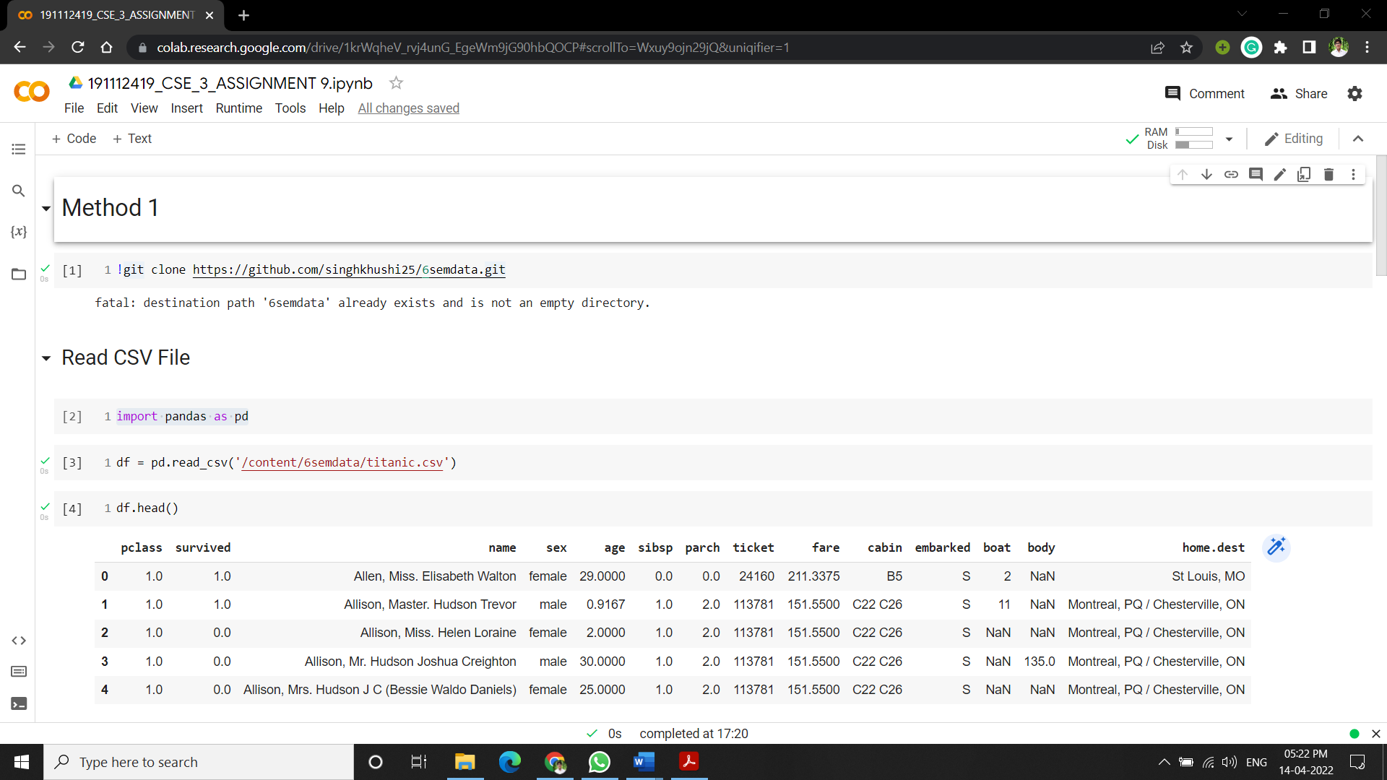

### Read Excel File

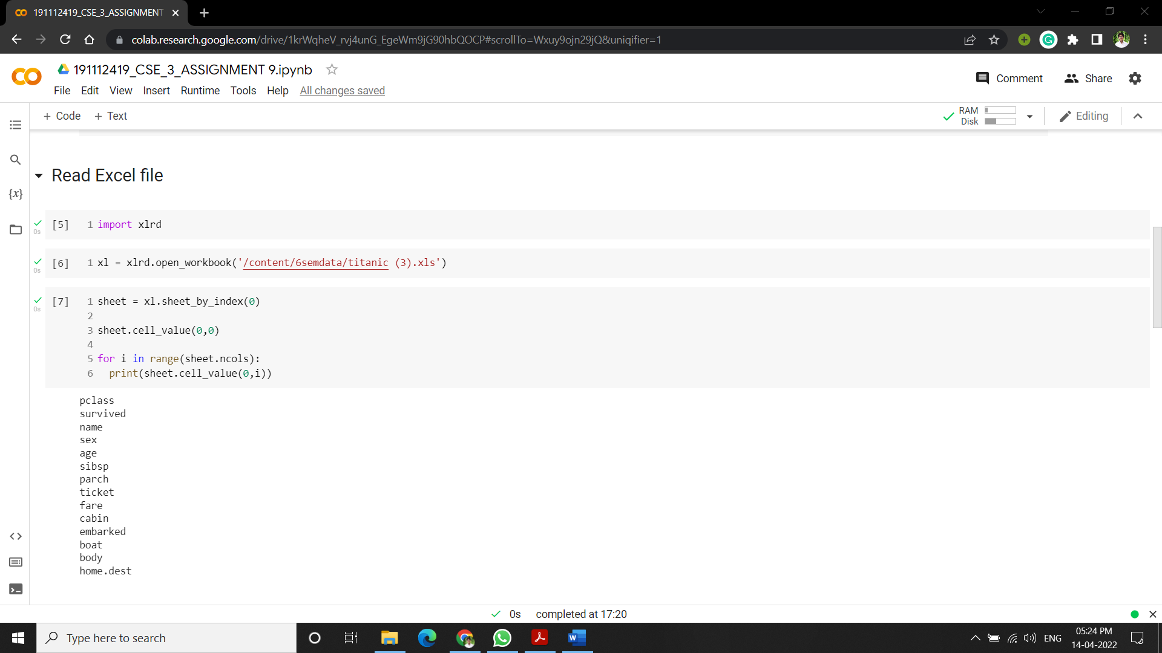

# Method 2

### Read CSV file

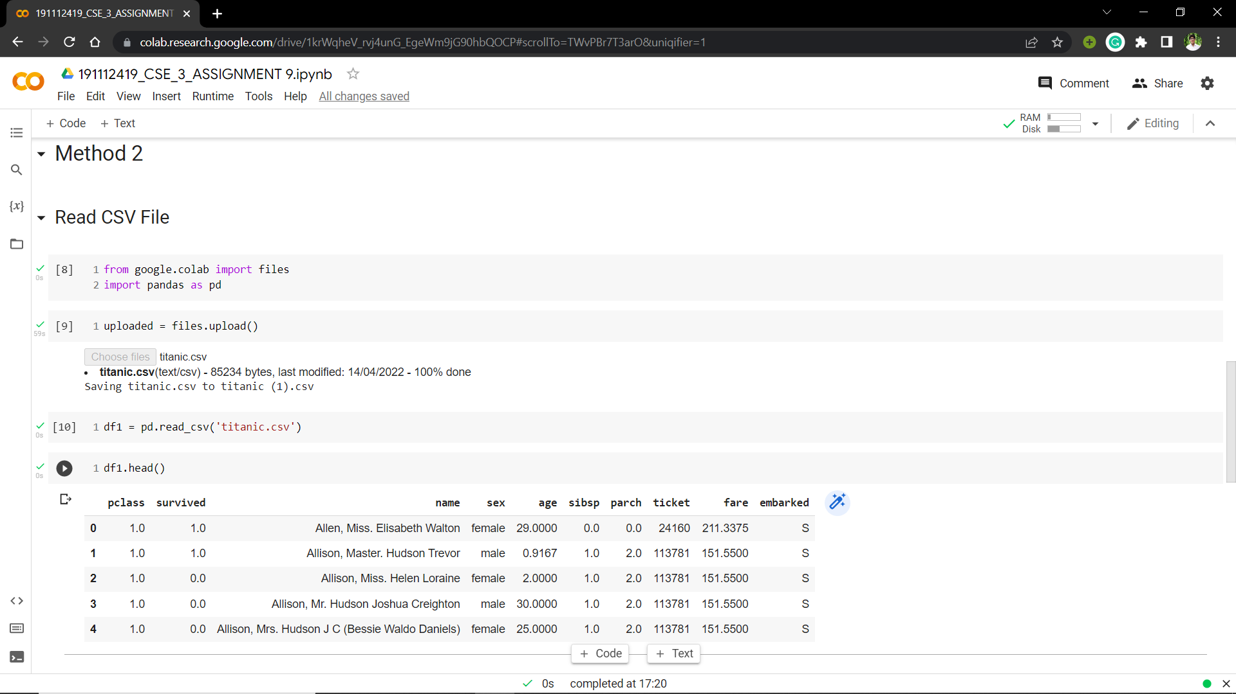

### Read Excel file

